Shashank Kumar
CTO and Co-Founder, Razorpay
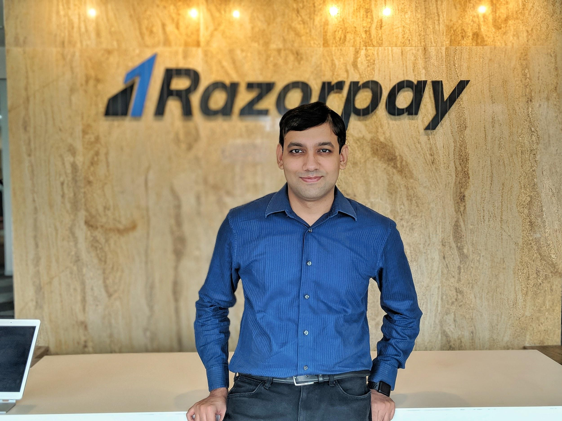
Shashank started Razorpay, along with Harshil Mathur, after discovering the dismal state of online payments in India. He graduated from IIT Roorkee and before taking the entrepreneurial route with Razorpay; Shashank also worked with Microsoft US as a Software Developer.

With an idea to change the way online payments function in India, Shashank quit his full time job. By early 2014, Razorpay was conceptualized with a vision to simplify online payments.
Razorpay is one of the only two India-focused companies to be selected for the prestigious Y Combinator (YC) programme. Along with 33 reputed investors, the company is also backed by GIC, Ribbit Capital, Sequoia Capital India, Tiger Global Management, Y Combinator, Matrix Partners and Mastercard with a funding of $366.5 Mn from Series A, B, C, D and E rounds.

Three years since its founding, Razorpay rebranded itself in 2017 as Razorpay 2.0, a Converged Payments Solution company with a product suite designed to ease businesses of managing concerns around the flow of money in their financial systems. In 2019, Razorpay acquired two companies - Opfin, a Payroll and HR Management Software company, to solve for seamless automation of a business’s entire payroll process and Thirdwatch, an Artificial Intelligence (AI) driven company specialising in big data and machine learning for real-time fraud prevention. Progressing in its journey that started with Razorpay 2.0, the Company also launched it’s neobanking platform, RazorpayX and lending platform, Razorpay Capital - both designed to power the financial systems for disruptive companies.

Razorpay has been charting exponential growth since its inception. In the last six years, the company has powered digital payments for over 5 Mn businesses including the likes of Facebook, Airtel, BookMyShow, Ola, Zomato, Swiggy, Cred, ICICI Prudential among others and is all set to reach 10 Million businesses by 2021. In the last six months, Razorpay has witnessed a 40-45% growth, month-on-month. The company now plans to further solidify its position as one of the largest full-stack fintech companies in the country. This full-stack financial services company expects a 4x growth in its revenue in this year, 2021.
Shashank was featured in an eclectic list of 30 promising young Indian talents under the age of 30, by Forbes Magazine (2017) and 40 Under 40 by Fortune India (2019). Shashank has also been featured in Entrepreneur magazine as ‘Top 35 Under 35’ entrepreneurs (2021).

