Amitabh Tewary Chief Innovation Officer,Razorpay

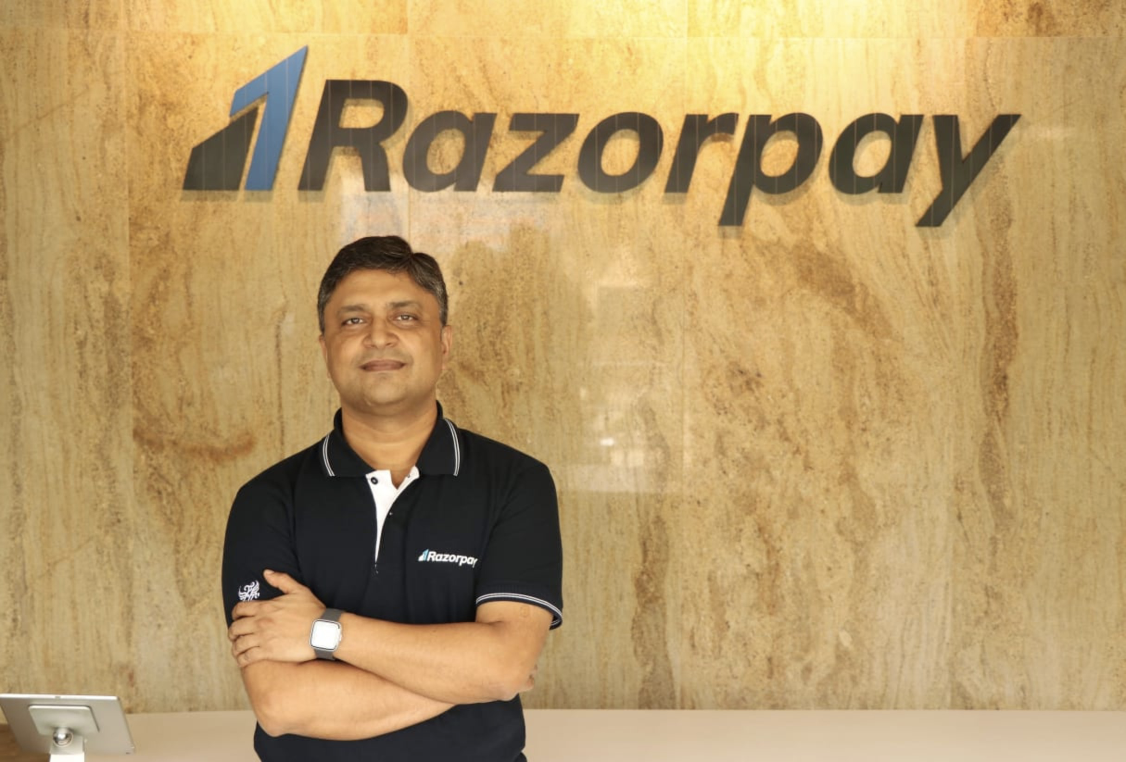
Amitabh Tewary, is the Chief Innovation Officer at Razorpay. Amitabh,will be responsible for expanding Razorpay’s footprint in other key markets and accelerating the adoption of new payment and banking platforms and products. A veteran in the space, he will be playing a key role in leading engagement with banks, networks, regulators, and strategic partners to drive innovation at Razorpay.
At Mastercard, as a Vice President, Tewary worked across a spectrum of roles driving strategic initiatives and partnerships, customer economics and enterprise risk management among others, for nearly a decade. Prior to this, he spearheaded different projects across business strategy, finance, sales, marketing and regulatory management, helping companies such as SBI Card, Thomas Cook and an edu-tech startup to identify new business opportunities and develop new technical capabilities.

